TryHackMe · Tutedude Cybersecurity Track · Task 07
Admin Panel
Access Control Vulnerability — Session & Cookie Manipulation
Platform: TryHackMe Room: tutedude-cybersec Category: Broken Access Control
Prepared by: Farhan Date: August 16, 2026
FLAG CAPTURED
FLAG{ADMIN_PANEL_ACCESS}

Objective
This task targets the SecureCorp Portal, a TryHackMe lab application, with the goal of locating and accessing its administrative panel by exploiting a flaw in how the application enforces access control. Credentials for a standard, low-privileged account were obtained in a prior task via review of the client-side source code; this task picks up from that authenticated foothold and focuses on privilege escalation through session and cookie manipulation.

Environment & Tools
Target | SecureCorp Portal — http://192.168.155.129/ (TryHackMe lab instance)
Platform | TryHackMe — tutedude-cybersec room
Tools Used | Gobuster v3.8.2, Burp Suite (Proxy / Repeater), Chromium-based browser
Wordlist | SecLists — Discovery/web-content/common.txt

Methodology

Step 1 — Directory & File Enumeration
The engagement began with content discovery against the web root using Gobuster, targeting common PHP/HTML/TXT resources with SecLists' common.txt wordlist:
gobuster dir -u http://192.168.155.129/ \
-w C:\wordlists\SecLists\Discovery\web-content\common.txt \
-t 5 --timeout 60s \
-x php,html,txt \
-o C:\results.txt
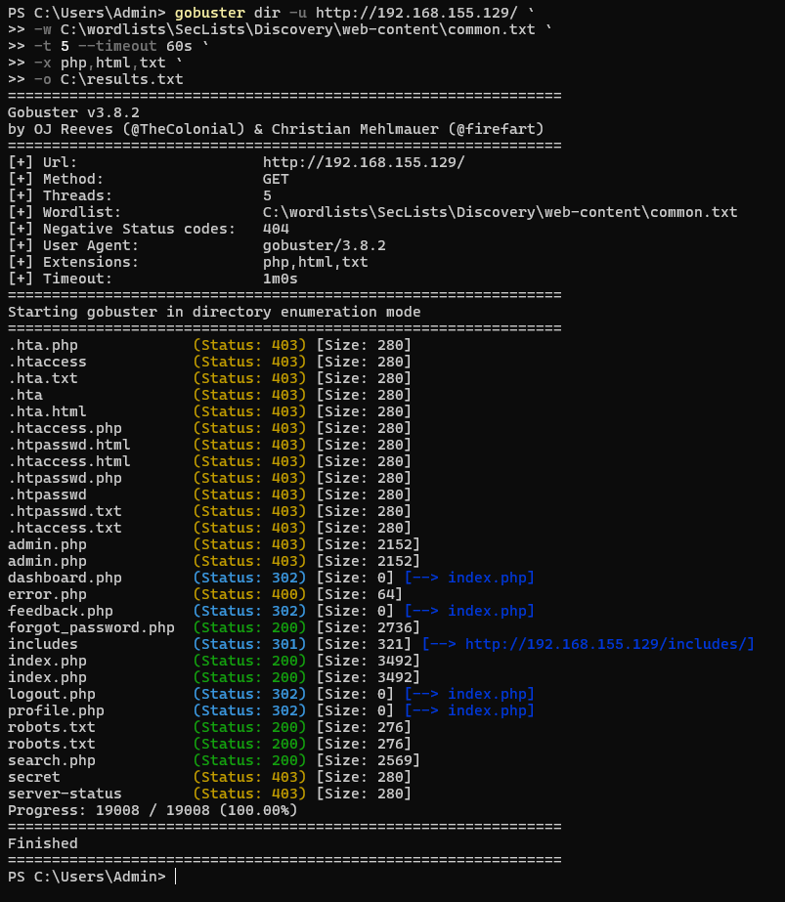
Figure 1 — Gobuster output enumerating the target's directories and files.
The scan surfaced several interesting endpoints, most notably admin.php, which returned HTTP 403 rather than 404 — confirming the resource exists but is being actively blocked — and dashboard.php, which returned a 302 redirect. Both are strong signals that the application implements some form of role-based access gate, and the fact that admin.php renders a real 2152-byte response rather than being silently dropped means the check happens at the application layer.
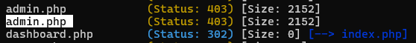
Figure 2 — admin.php (403) vs. dashboard.php (302): a role check is clearly active.

Step 2 — Confirming the Access-Control Check
Logged in as the low-privileged john account, a direct browser request to /admin.php was met with an application-level 403: “Your current role (employee) is not authorized to view this management console.” This confirms the role check is enforced by the application itself — and, critically, that the role is a value the app reads and evaluates per request, which raises the question of where that value actually lives.
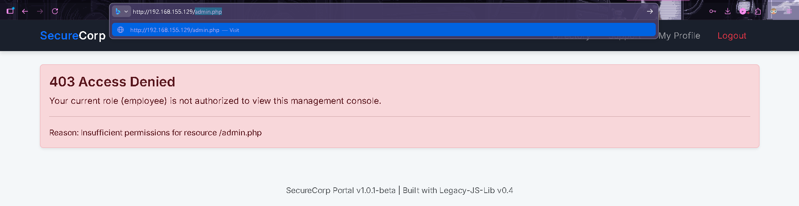
Figure 3 — Direct request to /admin.php as the 'john' (employee) account is rejected.

Step 3 — Intercepting the Request in Burp Suite
Routing the same request through Burp Suite's proxy revealed the answer. Alongside the standard PHPSESSID session identifier, the request carried a second, independent cookie, sent in plain text:
Cookie: PHPSESSID=4ougrdo3o8qro128p6tni899vk; user_role=employee
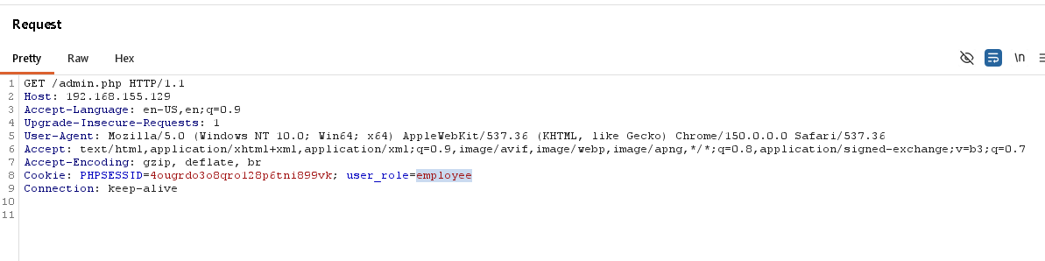
Figure 4 — Burp Suite Proxy: the role is carried in a plain, client-readable user_role cookie.
Rather than deriving the user's role from the authenticated server-side session, the application trusts this client-supplied cookie value directly. Since nothing about the cookie is signed or bound to the session, it is trivially editable by the client.

Step 4 — Exploiting via Cookie Manipulation
With Intercept active in Burp Suite, the user_role cookie value was changed from employee to admin and the request was forwarded with the path pointed at /admin.php:
GET /admin.php HTTP/1.1
Cookie: PHPSESSID=4ougrdo3o8qro128p6tni899vk; user_role=admin
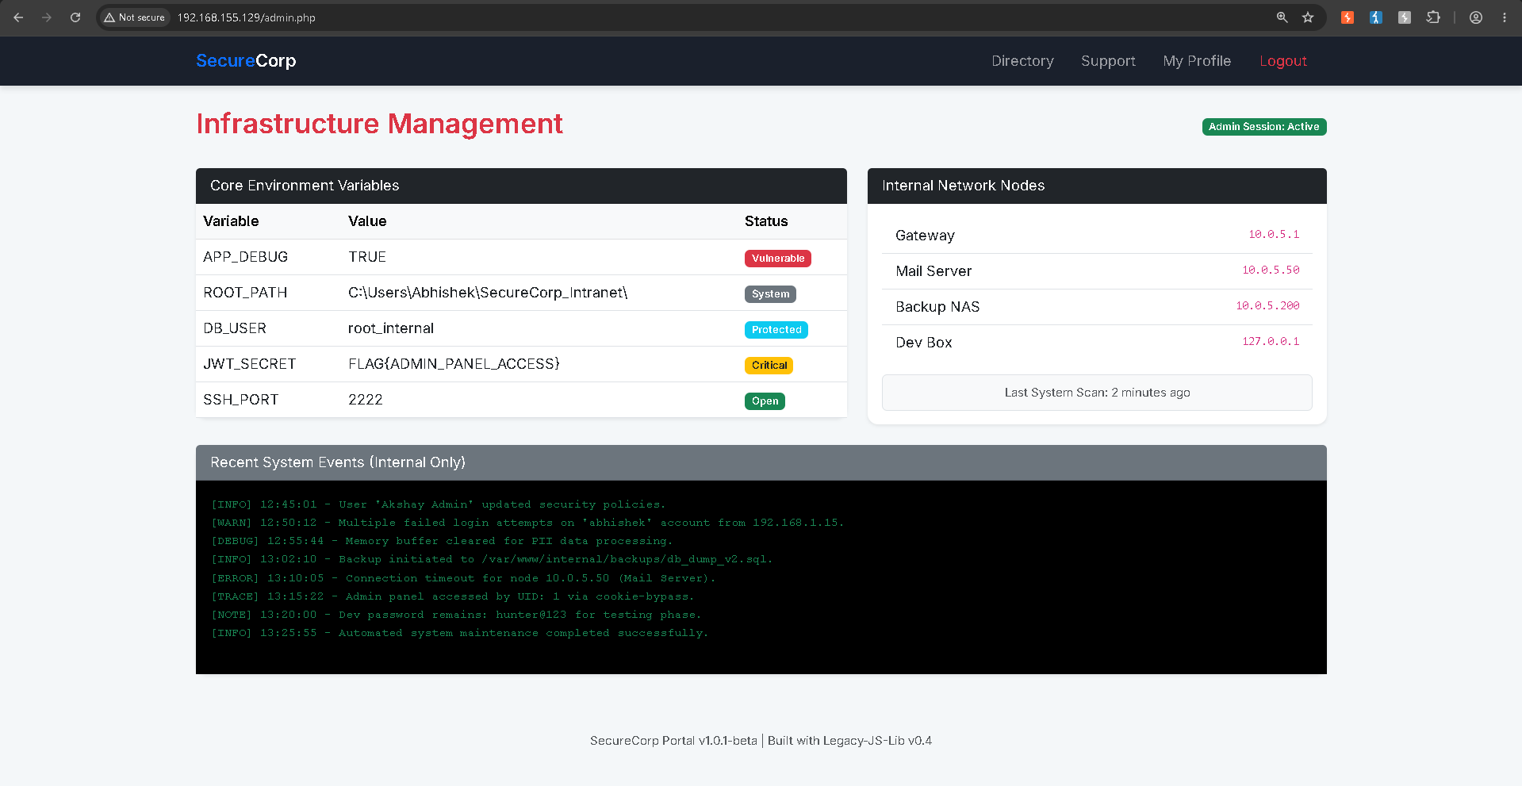
Figure 5 — The tampered request against /admin.php returns the full admin dashboard, no further authentication required.
Replaying the resulting response in the browser rendered the full “Infrastructure Management” admin dashboard, complete with an “Admin Session: Active” badge — confirming the bypass succeeded.

Step 5 — Flag Capture & Validation
The admin dashboard's “Core Environment Variables” table exposed the JWT_SECRET value, which contained the task flag. Beyond the flag itself, the same panel disclosed internal network topology (gateway, mail server, backup NAS, and dev box addresses), the internal database username, and a live system event log — one entry of which explicitly logged “Admin panel accessed by UID: 1 via cookie-bypass,” confirming the application detects this exact bypass pattern but does not block it.
Figure 6 — Flag accepted on TryHackMe.

Vulnerability Analysis
Vulnerability | Broken Access Control — authorization decided from a client-supplied cookie
OWASP Category | A01:2021 – Broken Access Control
Weakness (CWE) | CWE-639: Authorization Bypass Through User-Controlled Key
Severity | High / Critical — full admin panel takeover, no server-side verification

The root cause is a misplaced trust boundary: SecureCorp Portal performs authorization by reading a role claim from a cookie that the client fully controls, instead of resolving the role from the authenticated session on the server. Because the cookie is neither signed nor cryptographically bound to the session, any client can self-assign any role simply by editing a header — turning what looks like a role check into a client-side suggestion rather than an enforced control.

Impact
- Complete bypass of the admin authorization check using only an intercepting proxy — no credential theft or exploit chain required beyond editing a cookie.
- Exposure of internal environment configuration, including the JWT_SECRET, the database username, and the application's filesystem root path.
- Disclosure of internal network topology — gateway, mail server, backup NAS, and dev box addresses — which would materially assist an attacker pivoting deeper into a real network.
- A plaintext development credential recorded in the system event log, showing how a broken access control flaw compounds with secondary data-handling weaknesses.
- Evidence that the application logs suspicious access ('cookie-bypass') without alerting or blocking — detection without enforcement provides no real protection.

Remediation Recommendations
- Resolve the user's role server-side from the authenticated session store on every request; never accept a role, permission, or identity claim supplied directly by the client.
- If a client-visible token is required, use a signed and properly verified token (e.g. JWT with server-side signature validation) rather than a bare, editable cookie value.
- Apply centralized authorization middleware in front of all /admin* routes so the check cannot be missed on any individual endpoint.
- Strip verbose diagnostic data (env vars, secrets, internal IP ranges) out of any UI — admin included — and gate genuinely sensitive data behind additional controls and auditing.
- Escalate the existing 'cookie-bypass' detection from a passive log entry into an active alert, and consider automatically invalidating the session on detection.
- Treat any credential that ever touched a log file as compromised — rotate it, and move sensitive fields out of application logs entirely.

Conclusion
This task demonstrates a textbook Broken Access Control vulnerability (OWASP A01:2021): an authorization decision made on data the client is free to modify. Enumerating the target surfaced a gated admin endpoint, and a single cookie edit in Burp Suite was sufficient to fully bypass that gate and capture the flag. The exercise reinforces a core access-control principle — authorization must always be enforced and re-verified server-side, never inferred from anything the client sends.

FLAG{ADMIN_PANEL_ACCESS}

